## Reports/ Audit / Temp User Report:

Request:

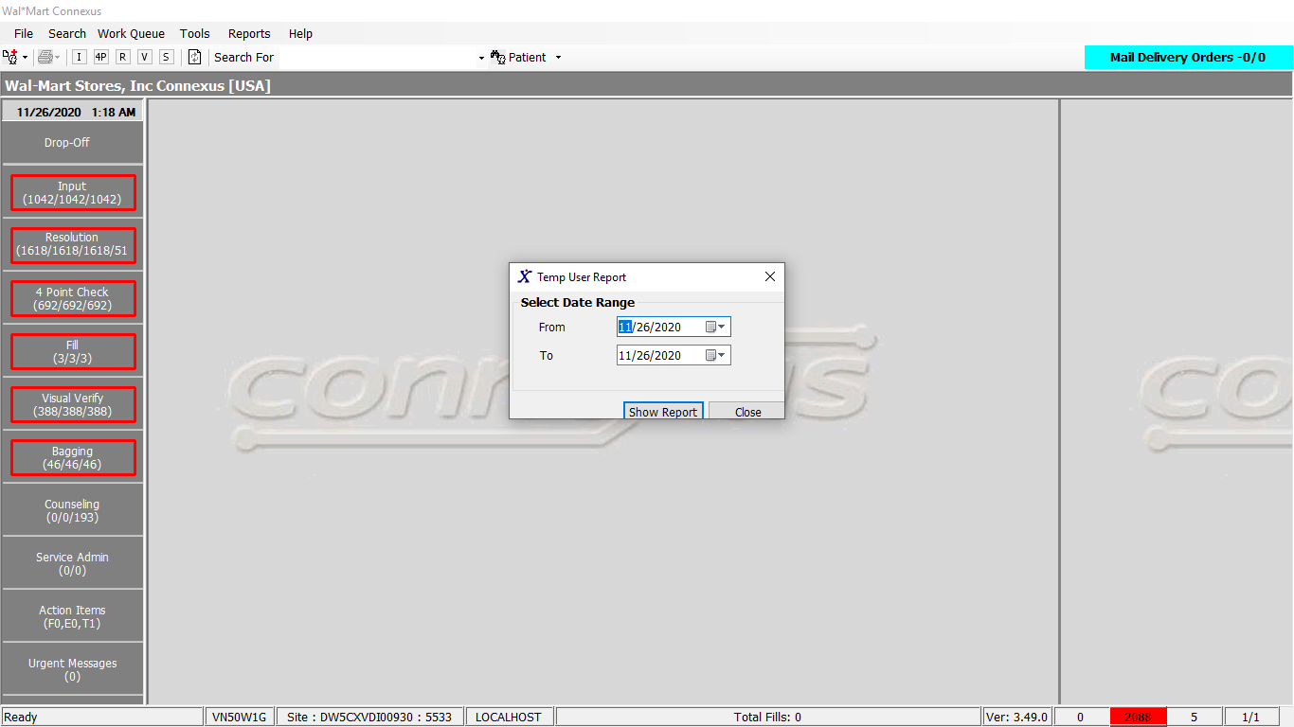

Response:

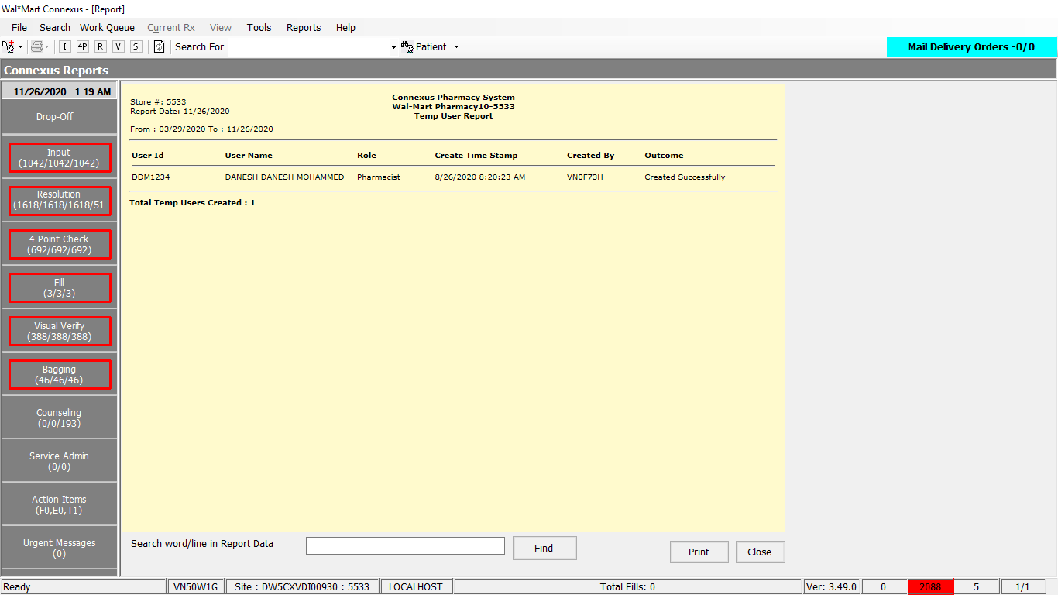

Queries

Public Const GetTempUserInfo As String = " SELECT activity_ts,activity_comment " &

" FROM appl_activity " &

" WHERE DATE(activity_ts) BETWEEN ? AND ? " &

" AND activity_type_code = ?" &

" AND process_id = ? " &

" AND task_id = ? " &

" ORDER BY activity_ts"

DAL:

Public Function GetTempUserData(ByVal siteId As Integer, ByVal startDate As Date, ByVal endDate As Date) As List(Of TempUserInfoBE) Implements IReportDAL.GetTempUserData

Using (New Tracer(ConnexusCommonConstants.ConnexusTracer))

Dim info As List(Of TempUserInfoBE) = Nothing

Dim AuditSerializer As Xml.Serialization.XmlSerializer = CacheWrapperDal.AuditSerializer

Dim auditInfo As List(Of Audit.AuditEntry) = Nothing

Dim reader As IO.TextReader = Nothing

Dim parameterlist As New List(Of DbParameter)

parameterlist.Add(ParameterHelper.BuildParameter("ActivityDate", DbType.Date, startDate))

parameterlist.Add(ParameterHelper.BuildParameter("ActivityDate", DbType.Date, endDate))

parameterlist.Add(ParameterHelper.BuildParameter("ActivityTypeCode", DbType.Int32, Audit.AuditActivityType.TempUserLog))

parameterlist.Add(ParameterHelper.BuildParameter("ProcessId", DbType.Int32, ServicesCommonConstants.AuditConnexusProcessID))

parameterlist.Add(ParameterHelper.BuildParameter("TaskId", DbType.Int32, ServicesCommonConstants.AuditConnexusTaskID))

Using dr As IDataReader = ExecuteReader(DatabaseEnum.Error_And_Audit, siteId, ReportQueries.GetTempUserInfo, parameterlist)

While dr.Read

Dim item As New TempUserInfoBE

If Not dr.IsDBNull(dr.GetOrdinal("activity_ts")) Then

item.CreateTS = dr.GetDateTime(dr.GetOrdinal("activity_ts"))

End If

If Not dr.IsDBNull(dr.GetOrdinal("activity_comment")) Then

reader = New IO.StringReader(dr.GetString(dr.GetOrdinal("activity_comment")))

auditInfo = CType(AuditSerializer.Deserialize(reader), List(Of Audit.AuditEntry))

For Each auditEntry As Audit.AuditEntry In auditInfo

If auditEntry.Name.Equals(TempUserAuditInfo.UserId.ToString, StringComparison.InvariantCultureIgnoreCase) Then

item.UserId = auditEntry.Value

End If

If auditEntry.Name.Equals(TempUserAuditInfo.Role.ToString, StringComparison.InvariantCultureIgnoreCase) Then

item.Role = auditEntry.Value

End If

If auditEntry.Name.Equals(TempUserAuditInfo.FullName.ToString, StringComparison.InvariantCultureIgnoreCase) Then

item.UserDescription = auditEntry.Value

End If

If auditEntry.Name.Equals(TempUserAuditInfo.CreateUserId.ToString, StringComparison.InvariantCultureIgnoreCase) Then

item.CreateUser = auditEntry.Value

End If

If auditEntry.Name.Equals(TempUserAuditInfo.Success.ToString, StringComparison.InvariantCultureIgnoreCase) Then

item.Result = auditEntry.Value

End If

Next

End If

If info Is Nothing Then

info = New List(Of TempUserInfoBE)

End If

info.Add(item)

End While

End Using

Return info

End Using

End Function